**To-Do List**

**Revised Prototype Document**

Project 2, Team 6

**Overview**

The To-Do List application will have the following modules: Sign up, Login, Task manage, Task view and Help information. And these modules and corresponding functions will be presented in the following pages: Sign up page, Login page, MainActivity page, Add/edit task page, View detail page, Sort Items Page, Hide Items Page and Help information page.

**Sign up Page**

The sign page allows new users to create an account with a username, password and valid email address. The account information will be stored in the built-in database.

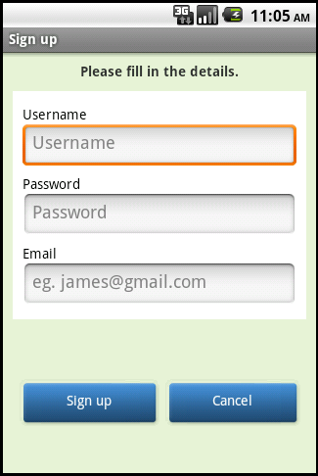

**Login Page**

For an existing user, he/she can login with valid username and corresponding password.

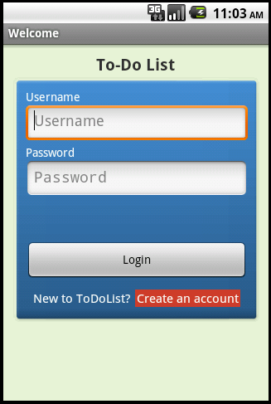

**MainActivity Page**

Once having logged in, the user can observe and interact with the main activity page. This page will display a list of tasks that the user has to accomplish, with the task name, due date and priority. The user can select one or more tasks by ticking the checkbox and choose to delete or hide (implicating the task has been accomplished) the selected tasks. The user can also click on a specific task to view detailed information about the task (See view detail page). By clicking “ToDo” “Due Date” or “Priority”, the user can sort the listed tasks by name, due date and priority, respectively. The user can also choose to show all hidden tasks by clicking on the “Hidden Items” menu button. A new page for adding tasks will appear when the user clicks on the “Add” button.

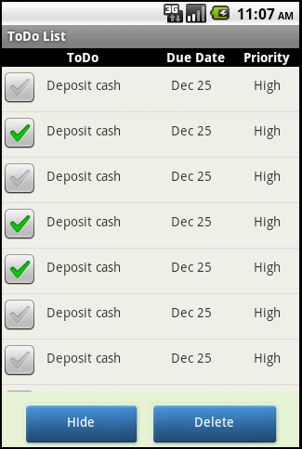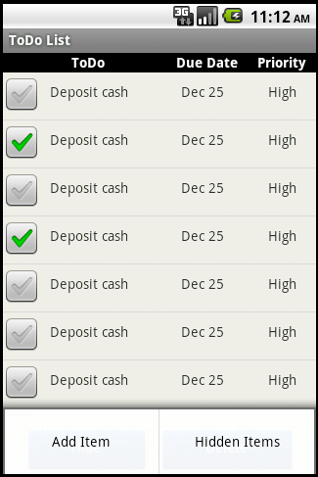

**View Detail Page**

The user can view detailed information about the task by clicking on a specific task. Detailed information includes task name, priority, start date, due date and notes. The “Edit” button allows the user to edit detailed information of the task.

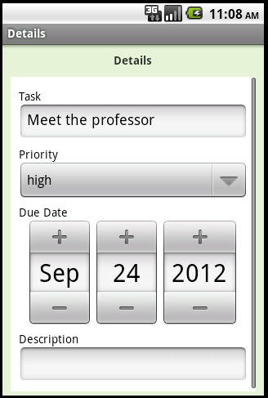

**Add/Edit Task Page**

The user can add tasks by clicking on the “Add” button on MainActivity page or edit an existing task by clicking on “Edit” button on the View Detail Page. The user can specify the name, priority and due date of the task. Priority is specified by selecting from a dropdown list with options of “High”, “Medium” and “Low”. Due date can be chosen from a calendar.

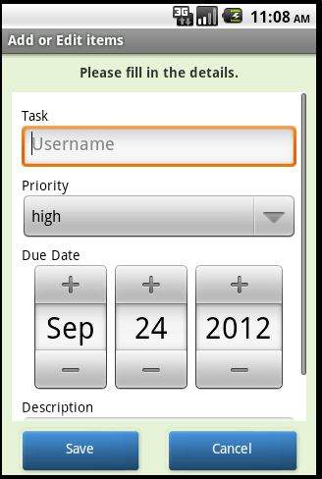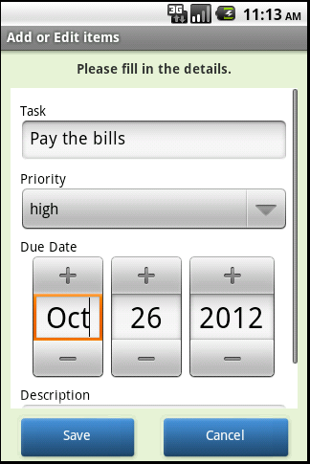

**Help Menu Screen**

This screen displays the information about the functionality of the application. The user can access this by clicking on the “i” Button on the top right corner of any screen in our application.

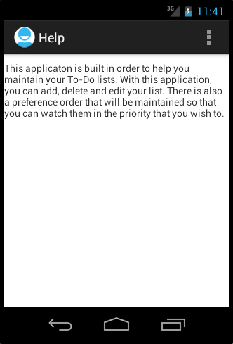

**Sort Items Page**

This functionality helps to sort the tasks based on date and priority. This enables the user to view his tasks based on a specific criteria and helps him to ease out his view as he desires.

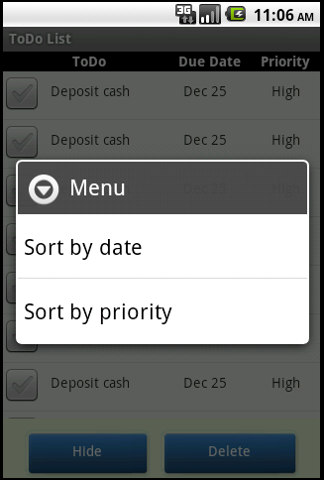

**Hidden items Page**

This page displays the tasks that the user chose to hide. This page will give the user the functionality to unhide them whenever he wishes. He can also choose to delete these items if he wishes to.

